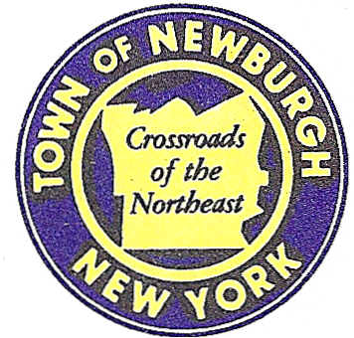

TOWN OF NEWBURGH
_______Crossroads of the Northeast __________________________
OLD TOWN HALL
308 GARDNERTOWN ROAD NEWBURGH, NEW YORK 12550

PLANNING BOARD
JOHN P. EWASUTYN, CHAIRMAN
TELEPHONE 845-564-7804
FAX 845-564-7802
E-MAIL: planningboard@townofnewburgh.org

PLANNING BOARD AGENDA

May 5th, 2016

*PLEASE NOTE: The Planning Board Meeting will start at 7:00 P.M. and all Applicants/Representatives
are to be present at that time. The Meeting will be held in the Meeting Room of Town Hall,
located at 1496 Route 300, Newburgh NY.*

1. Frischknecht (2015-06) 2 LOT SUBDIVISION
2 Chevy Lane PUBLIC HEARING
Section 70, Block 3, Lot 1
Zone: R-3
Rep: Jonathan Cella, P.E.
51 Hunt Road
Wallkill, NY 12589

2. Mavis/Mixed Use (2015-03) SITE PLAN ARB
1413 Union Avenue
Section 60, Block 3, Lot 40.2
Zone: IB
Rep: Bohler Engineering
5 Computer Drive West, Suite 203
Albany, NY 12205

3. Fischer (2015-31) AMENDED SITE PLAN
154 Route 17K
Section 94, Block 1, Lots 12,13,14,15
Zone: B
Rep: Vincent Doce Associates
242 South Plank Road
Newburgh, N.Y. 12550

4. Lands of Rudie & Albert (2016-06) INITIAL APPEARANCE
411/417 Lakeside Road LOT LINE CHANGE
Section 28, Block 1, Lot 15 & 36
Zone: R-1
Rep: KC Engineering and Land Surveying, P.C.
2142 Route 302
Circleville, NY 10919

5. Ridgeview Subdivision (2015-34) 2 LOT SUBDIVISION
3 Ridgeview Drive
Section 98,Block 1, Lot 14.3
Zone: R-3
Rep: Willingham Engineering
10 Main St. ,Suite 321
New Paltz, NY 12561

6. WTF NY, Inc. (2014-07) INITIAL APPEARANCE
979 & 983 Route 32 AMENDED SUBDIVISION
Section 2-Block 1- Lot 46 &42
Zone: RR
Rep: Talcott Engineering Design, PLLC.
1 Gardnertown Road
Newburgh, NY 12550

PLANNING BOARD BUSINESS
WORK SESSION

May 5, 2016

1. Elm Farm (2000-09) 6 month extension 5/5/2016 to 11/5/2016.

